

Python Project Report

TOPIC: Store Management

**Made by Pranav Balaji**

**Class: XI – A**

ACKNOWLEDGMENT:

This is to certify that Pranav Balaji of Apeejay School, Noida (Class: 11-A) has created a project on the topic “Store Management”, called as the “deltaStoreManager”.

He has generated this report after a lot of hard work. The report has been created under the guidance of the teacher

Mrs. Sujata Bhardwaj and qualifies the benchmarks for the Python Project.

ABOUT THE PROJECT:

The project is focussed on being an all-rounder solution for shops to handle their billing, customers and record-keeping needs.

The project asks the user to select from 5 options, namely:

* BILLING MODE
* NEW CUSTOMER REGISTRATION MODE

THIS PROJECT INCLUDES:

* VIEW ALL REGISTERED CUSTOMERS MODE
* VIEW ALL SALES RECORDS MODE
* EXIT PROGRAM OPTION

The same has been discussed in brief-detail below:

In the billing mode, the user is asked to enter the customer’s I.D. (if registered), and then asks for the number of items being purchased. Then it asks the user to enter each product’s code, followed by the tax and discount amount (can be zero) to be applied. The total amount is subsequently printed.

In the customer registration mode, the user is asked to enter the customer’s new I.D., full-name and email contact. The same is inserted into the SQL database.

In the view all registered customers mode, the program contacts the SQL database and displays the complete table of registered customers.

In the view all sales records mode, the program first asks the user to authorize the event by asking for a password (default = “root”). Upon successful authenication, the program opens the sales log externally, with the NotePad application (whichever app the system has installed to open .txt files by default would be used).

Upon selecting the fifth – exit option, the program exits.



FUNCTIONS USED:

**from datetime import datetime**

* A Python in-built function to display the system’s date and time.

**import mysql.connector**

* A function to connect and interact with SQL databases.

**import time**

* A Python in-built function used to specify delays in the program.

**import os**

* A Python in-built function used to open external applications.

**def mainmenu()**

* Self-defined function to display the main-menu of the menu-driven program.

**def inserter()**

* Self-defined funciton to take values from the user and insert them into the SQL database selected.

HARDWARE USED:

* CPU
* SSD or HDD
* RAM
* NETWORK (if using a non-local database)

SOFTWARE USED:

* Microsoft Windows 10
* Microsoft Office Word
* Microsoft Visual Studio
* GitHub by Microsoft



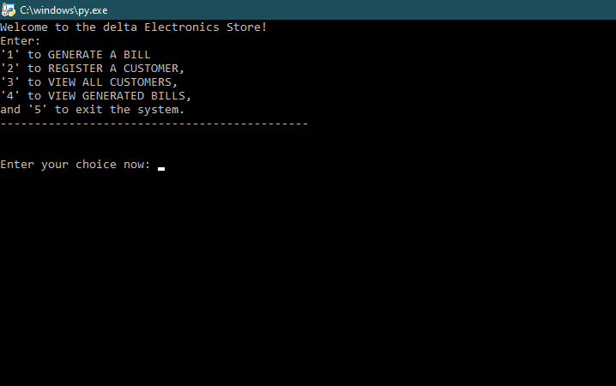OUTPUT:

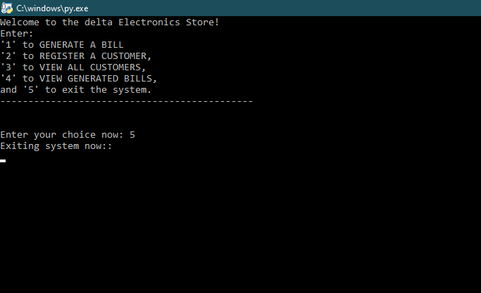HOME MENU : Initial boot-time screen

EXIT OPTION: Option 5

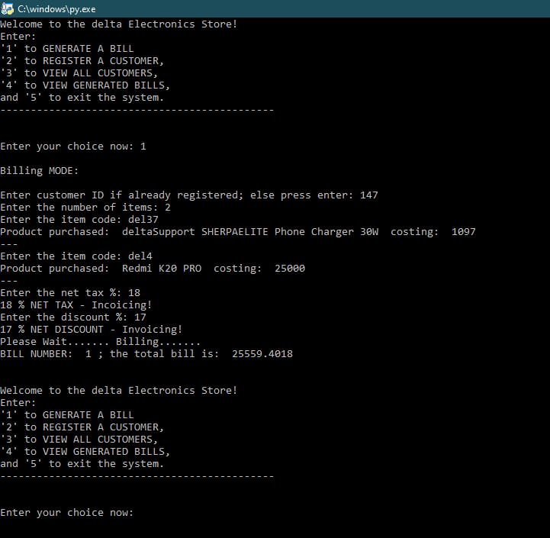

GENERATE A BILL – Option 1

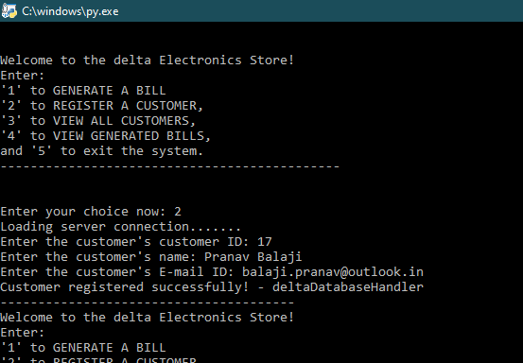

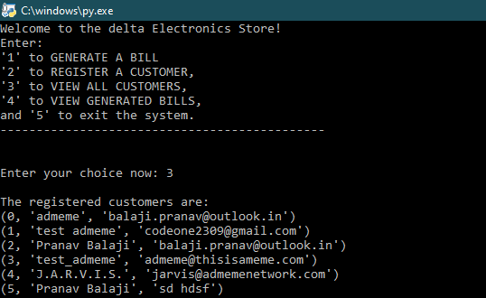REGISTER A CUSTOMER – Option 2

VIEW ALL REGISTERED CUSTOMERS – Option 3

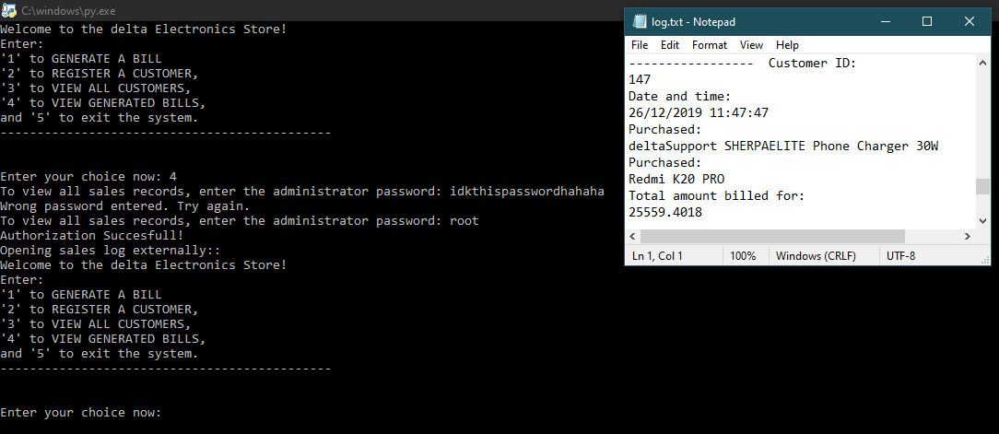VIEW ALL GENERATED BILLS (SALES LOG/ RECORD) – Option 4

GitHub:

This program repository has also been uploaded to the code sharing platform, GitHub:

Link to repository: deltaonealpha.github.io/dsmsapl



BIBLIOGRAPHY:

Works sighted from:

* StackOverflow: www.stackoveflow.com
* Google: www.google.com
* Core Python Programming by R. Nageshwar Rao



Thank You

Created by Pranav Balaji

Python Project Class – XI